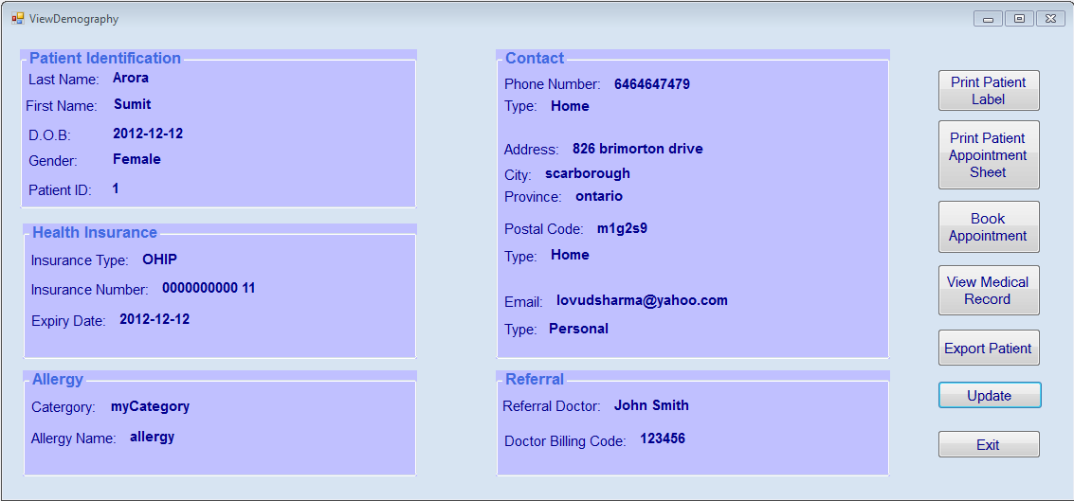

1. From the Search Patient window, if the patient is already registered, user can view his/her demographic

1. This view contains sufficient information to identify a patient (by Patient OHIP number)
2. User can have an overview of the patient through this window: name, age, contact, etc
3. There are some functional buttons located on the right side of the window:
   1. User can print Patient Lab by using DYMO Label printer, for example and attach to a lab requisition or referral letter

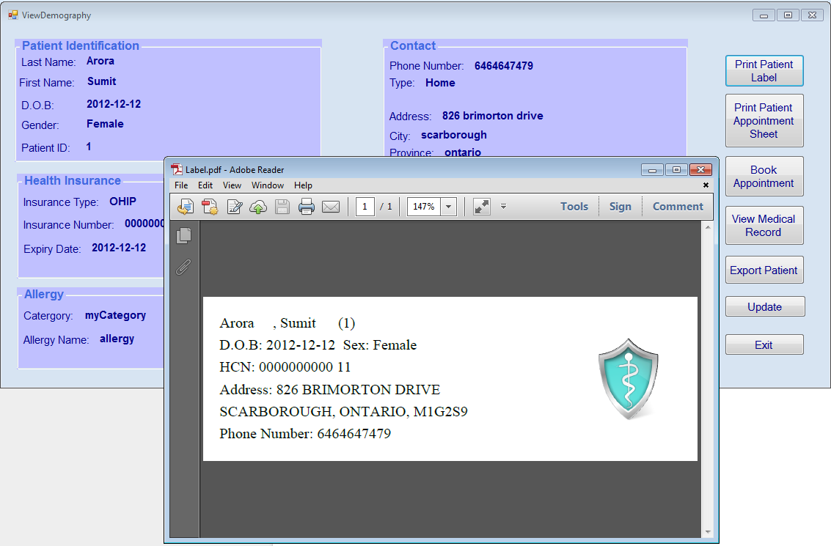

1. User can print Appointment Sheet. In some clinics, physicians are still using paper chart so they will use this paper to take note when seeing patient. Or it can be used by specialists who want to take notes and dictate after seeing patient.

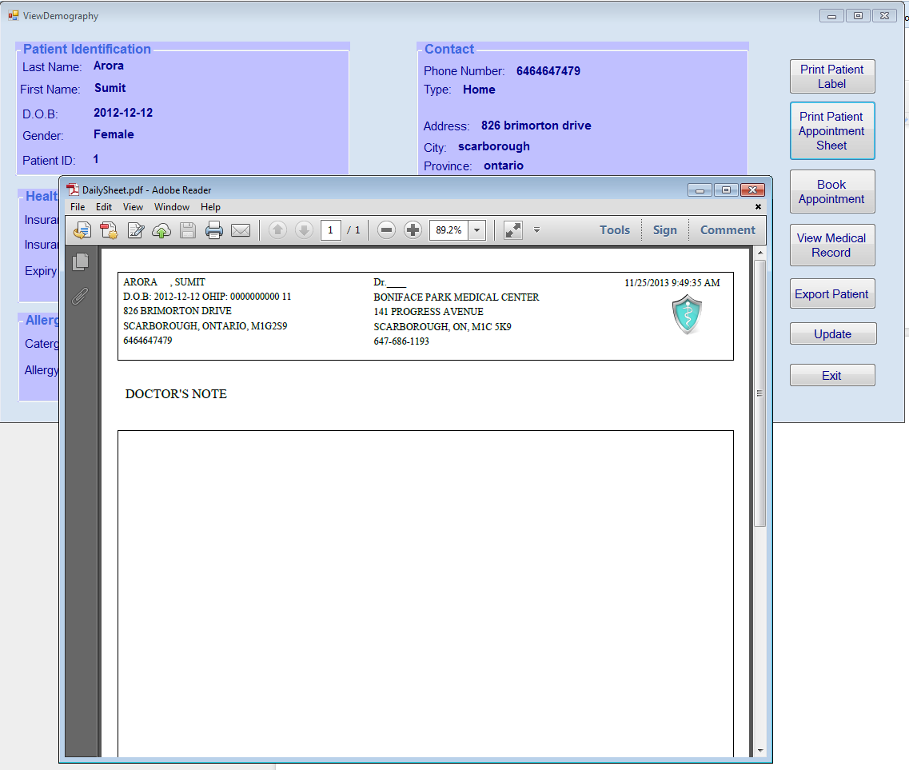

1. When a patient checks in at front desk, user is able to add patient to a list of the doctor he/she has an appointment today. Note: the drop down list only shows name of the doctor has schedule on that day.  If there is no doctor working on that day, the list will be blank.

